Annex II: Students’ sharing from Helios team
Ishana Lu Yu-chiao  Ishana Lu Yu-chiao is a year 3 student from Taiwan studying Mechanical Engineering at HKU. In the competition, she showcased her capabilities, such as language abilities, creating web and Facebook pages and writing technical reports. By discussing the car frame and structure design concepts with professors, she not only contributed a lot to the success of the team but also gained precious practical engineering knowledge. | 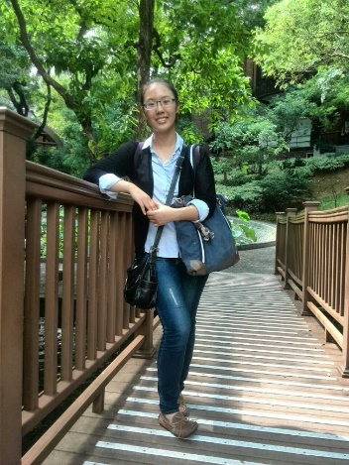
Kenneth Hui Ka-chun  Kenneth Hui Ka-chun is a year 1 student in the Faculty of Engineering. He was an energy conservation leader in the team and participated in designing the web and Facebook pages. These experiential learning exposures benefitted him a lot and enrich him in understanding the various engineering streams in his subsequent years of study. | 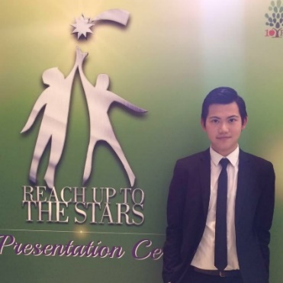
Benny Cheung Wing-lai  Benny Cheung Wing-lai is a year 3 undergraduate student studying Electrical Engineering. Benny started developing his interest in the engineering field in secondary school and joined the IET/MATE Hong Kong Underwater Robot Challenge. After entering HKU, he has worked on various projects related to robotics, computer vision and PCB design. He was the energy team leader responsible for designing the electrical and electronic systems of the car. He introduced new ideas such as a tablet control system which enhanced the user experience and performance of the car. | 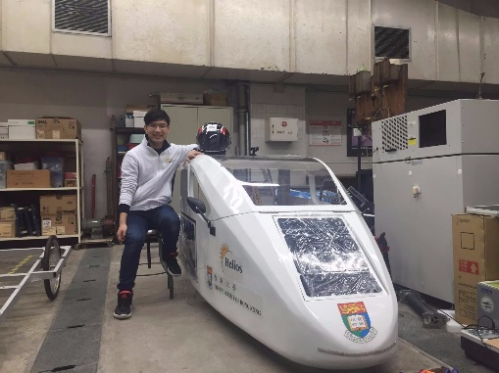
Curtis Wong Hon-leung  Curtis Wong Hon-leung is a year 3 student in the Mechanical Engineering Department of HKU. As a team member, he was mainly responsible for the design of the chassis. Curtis had the opportunity to learn the way to build a strong and energy-efficient car structure using the proper materials. He also enjoyed developing team-working skills in this project. | 